Analysis of the Potential Health Benefits of Reducing Ozone Levels in the OTR Using BenMAP

September 5, 2017
Prepared by Ozone Transport Commission

Introduction
In 2015, the 8-hour ozone National Ambient Air Quality Standard (NAAQS) was lowered to 70 ppb. This was the high end of the range recommended by the Clean Air Scientific Advisory Committee (CASAC) originally and in the rule proposal by Administrator McCarthy. The lower end of the range proposed by EPA was 65 ppb. Additionally, recent research has shown health effects from ozone occur at even lower levels. As a result three levels of ozone were investigated in this analysis: 70 ppb, 65 ppb, and 40 ppb.
Each year that air quality does not meet the NAAQS the health of the populations exposed to the poor air quality are impacted. As a result the analysis will focus on each ozone season for which data is available, 2013-2016.
Several states in the Ozone Transport Region (OTR) had monitored design values that were above the standard set by EPA. Given that the primary NAAQS are set to a level to adequately protect the public health, this implies that populations in the OTR would receive a health benefit if the entire OTR were to meet the NAAQS. This paper looks at the benefits that would have occurred each year from 2013-2016 had the entire OTR met the 2015 NAAQS as estimated by the Environmental Benefits Mapping and Analysis Program (BenMAP) Community Edition (CE) program.

Methods

Overview of the Health Impact Functions
BenMAP CE v1.3.52 was employed to process the health impact functions. These functions are developed to calculate the change in health incidence for a given population due to a change in air quality. The health impact functions typically consist of four variables: change in air quality, population, baseline incidence rate, and effect estimates that are drawn from epidemiological literature. The health impact functions used in the analysis were all functions provided in the downloadable version of BenMAP CE. The typical health impact function (Δy) is log-linear as follows:

Δy = y₀(e^{βΔq}-1)pop

where y₀ is the baseline incidence rate, β is the effect estimate, Δq is the change in air quality, and pop is the population.

Change in Air Quality
Monitored ozone data were obtained throughout the entire OTR and the states that border the region (Ohio, West Virginia, and the remainder of Virginia) for 2013-2016 from the Air Quality System (AQS) monitor network and the data was originally compiled by staff at the Maine Department of Environmental Protection. The Voronoi Neighborhood Averaging (VNA) inverse distance interpolation squared technique was used to interpolate to grid cells between monitors. The bordering states were included so that the VNA would not result in inappropriate values along the western and southern borders of the OTR. Monitored ozone data was not available from Canada, so VNA may create unexpected results along the northern border, but exceedances are less common in that region so the monitors would not be rolled back anyway. The national CMAQ grid was used rather than the grid clipped to the United States boundaries since using the latter resulting in data missing in many grid cells in Maine.
Annual ozone season data was imported, but in many cases monitors only are operated during a shorter time period when conditions are conducive to ozone formation as defined in federal regulations (see Table 1). Furthermore, BenMap requires that a certain thresholds to be met for the data at a particular monitor to be considered acceptable. The default time spans for data to be considered are too stringent since several monitors with 4th high 8-hour ozone values above 70 ppb would be excluded so the time span of April 1 – October 31 was used. 4th high 8-hour ozone data for each year seen in Figure 1 though Figure 4 and data for the 20 worst monitors in the OTR can be seen in Table 2.
Table 1: Ozone Monitoring Season Requirements (40 CFR 58 Appendix D (4)(i))
State | Start Date | End Date
Connecticut | March 1 | September 30
Delaware | March 1 | October 31
District of Columbia | March 1 | October 31
Maine | April 1 | September 30
Maryland | March 1 | October 31
Massachusetts | March 1 | September 30
New Hampshire | March 1 | September 30
New Jersey | March 1 | October 31
New York | March 1 | October 31
Pennsylvania | March 1 | October 31
Rhode Island | March 1 | September 30
Vermont | April 1 | September 30
Virginia | March 1 | October 31

Figure 1: 4th high monitored 8-hour ozone values for 2013  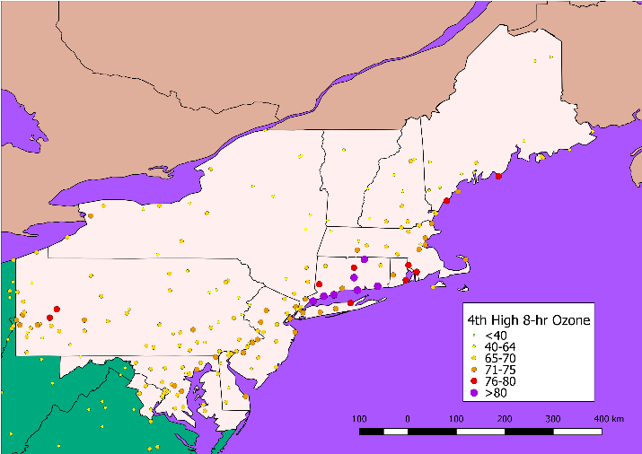 | Figure 2: 4th high monitored 8-hour ozone values for 2014  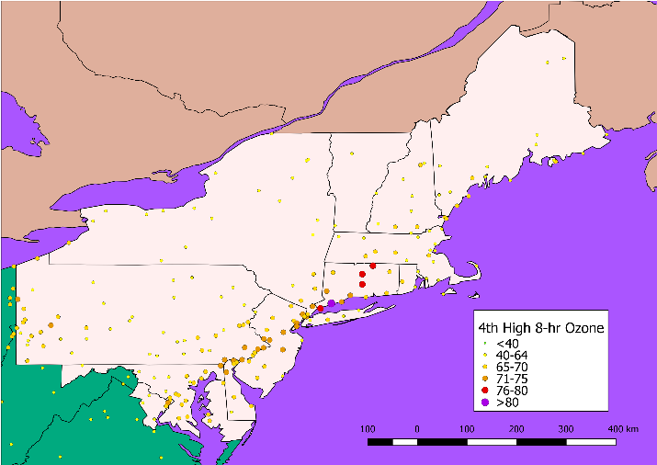
Figure 3: 4th high monitored 8-hour ozone values for 2015  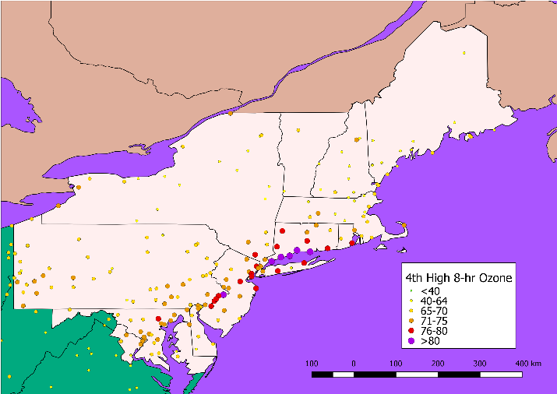 | Figure 4: 4th high monitored 8-hour ozone values for 2016  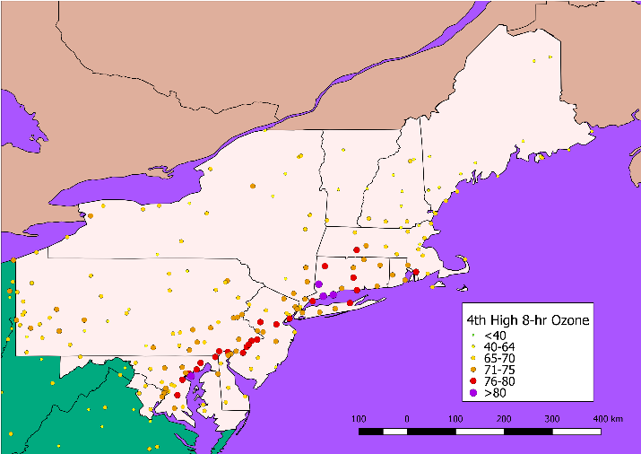
Table 2: 4th Highest 8-hour Ozone Concentrations from 2013 - 2016
Agency | Site Name | AQS Code | 4th Highest 8-hr Ozone Concentrations |  |  |  | Average 2013-16 4th High
 |  |  | 2013 | 2014 | 2015 | 2016
CT | Westport | 90019003 | 86 | 81 | 87 | 87 | 85
CT | Stratford | 90013007 | 90 | 74 | 86 | 83 | 83
CT | Greenwich | 90010017 | 82 | 78 | 84 | 79 | 81
CT | Middletown | 90070007 | 82 | 80 | 78 | 80 | 80
CT | Madison-combined (3002 9002) | 90099002 | 85 | 69 | 81 | 80 | 79
CT | Danbury | 90011123 | 76 | 74 | 79 | 81 | 78
PA | Bristol | 420170012 | 73 | 71 | 82 | 80 | 77
CT | East Hartford | 90031003 | 77 | 77 | 75 | 75 | 76
CT | New Haven-B | 90090027 | 75 | 72 | 81 | 75 | 76
CT | Groton Fort Griswold | 90110124 | 85 | 65 | 77 | 75 | 76
CT | Stafford | 90131001 | 81 | 77 | 72 | 72 | 76
MD | Fair Hill | 240150003 | 72 | 74 | 74 | 80 | 75
NY | NYC-Susan Wagner HS | 360850067 | 71 | 72 | 79 | 77 | 75
PA | NEA | 421010024 | 68 | 72 | 79 | 80 | 75
NJ | Leonia | 340030006 | 74 | 73 | 76 | 75 | 75
NY | Riverhead | 361030004 | 78 | 64 | 76 | 78 | 74
NJ | Clarksboro | 340150002 | 73 | 70 | 76 | 76 | 74
NJ | Rutgers U | 340230011 | 70 | 71 | 77 | 76 | 74
NY | White Plains | 361192004 | 72 | 74 | 73 | 75 | 74
MD | Edgewood | 240251001 | 72 | 67 | 74 | 79 | 73

After importing each year’s monitored ozone data, BenMAP CE was employed to conduct an analysis termed “roll back.” In this approach a mathematical technique is used to reduce the ozone values at the monitors so that each meets a threshold, in these cases a 4th highest daily maximum 8-hour ozone average concentration of 70 ppb, 65 ppb, or 40 ppb. Technically to demonstrate compliance with the 8-hour ozone NAAQS, the average of 3 years of the 4th highest daily maximum 8-hour ozone averages is calculated and referred to as a design value (DV) This is necessary since BenMAP CE only accepts one year worth of air quality data in an analysis. After the “roll back” is complete, the monitor data was then interpolated geographically using an inverse distance weighting technique.
There are three techniques for rolling back the monitored values to the standard: percentage reduction, incremental, and peak shaving that need to be applied to the inter-day and intra-day rollback. The peak shaving technique was employed for the inter-day rollback so values meeting the standard would not have reductions applied, which would result in more conservative results. The percentage technique was employed for the intra-day rollback since it best reflected the implementation of measures that would affect each hour of the day equally.
In conducting the analysis, including a background rate was necessary to prevent monitors from being lowered below what would occur absent anthropogenic emissions. There are a variety of estimates for background, and even several values considered background (e.g., United States Background (USB) and North American Background (NAB). For this aspect of the modeling a value of 30 ppb was used which is associated with lower levels of NAB found in the Eastern United States in the summer time as was presented in Figure 3-9 of EPA’s Integrated Scientific Assessment for the 2015 Ozone NAAQS. Peak shaving was used as the inter-day rollback method and percentage reduction was used as the intra-day rollback method. In both cases 30 ppb was used for the background level.
One potential flaw with the rollback approach is that only monitors that have 4th highest values above 70 ppb were rolled back to the standard. However, in a case where controls are put on to achieve such a monitored level, downwind areas would also have reduced ozone concentrations even though their monitors are already below the standard. As a result, the health effects downwind, in New England in particular, are lower than what would be experienced in a real world scenario.

Population
US population data were based on estimates of populations in the corresponding year projected from 2010 block-level US Census data. The geographic extent of population was limited to the population that lives in the 12 full states in the OTR, the District of Columbia and the nine cities/counties in Virginia that are considered part of the OTR. The total population used for each year is in Table 2.
Table 2: Population by Year Analyzed
Year | 2013 | 2014 | 2015 | 2016
Population | 66,403,000 | 66,610,000 | 66,928,000 | 67,301,000

Selection of Health Impact Functions
There is evidence of a relationship between long-term exposure to concentrations of ozone and premature respiratory mortality, which is one of a few studies that detect an increase in mortality from long-term ozone exposure. However there remain questions as to whether long-term mortality has the same direct relationship to ozone exposure as short-term mortality does since this is a newer finding in the literature, so this paper will only examine short-term mortality. Additionally, several functions representing morbidity, including acute respiratory symptoms, respiratory hospital admissions, respiratory emergency rooms visits, and school loss days, were used, which are functions typically used in EPA studies. The process to aggregate the results of the health studies is in Figure 1.
Figure 5: Aggregation of Health Effects Studies
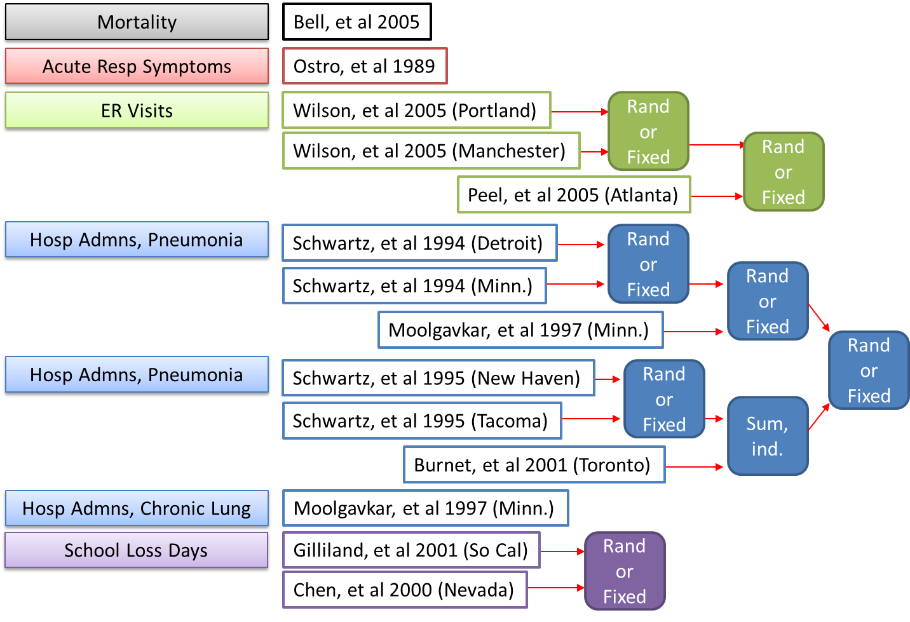

Baseline Incidence Rates
Baseline incidence rates that are part of EPA’s dataset were used in this analysis. Projections of mortality incidence rates were available for 2015 which coincided with one of the years analyzed so it was determined to be the most appropriate data set and were used in the mortality health impact functions. The incidence estimates for 2014 were used for the other health endpoints, since the incidence estimates also coincided with one of the years analyzed, excepting school loss days where 2000 was and acute respiratory systems which has a slightly different form than the other functions, so baseline incidence rates are not included in the equation.

Economic Analysis
In order to quantify the impact of the health benefits the reduced incidence is multiplied by a valuation estimated through one of several techniques. In the case of mortality, the Value of Statistical Life (VSL) based upon a normal distribution was used. The VSL uses differences in salaries and the inherent risk of a job to infer the rate at which life is valued. A Willingness to Pay (WTP) estimate was used to monetize acute respiratory symptoms. WTP relies on survey data to determine how much people value not having an adverse health effect. Cost of Illness (COI) estimates were used to value emergency room visits and hospital admissions. COI totals up the amount spent on medicine, hospital visits, etc. due to an adverse heath effect. Since the VSL is based on hedonic economic analysis it best characterizes the complete value of the effect, with the WTP estimates characterizing less of the true cost, and COI capturing the least of the true cost. The process undertaken to aggregate the economic results are in Figure 2.
Additionally, income effects were adjusted to the year analyzed and all valuations are in 2010 U.S. Dollars, inflated using the Consumer Price Index (CPI) and Employer Costs for Employee Compensation (ECEC).
Figure 6: Aggregation of Economic Evaluations
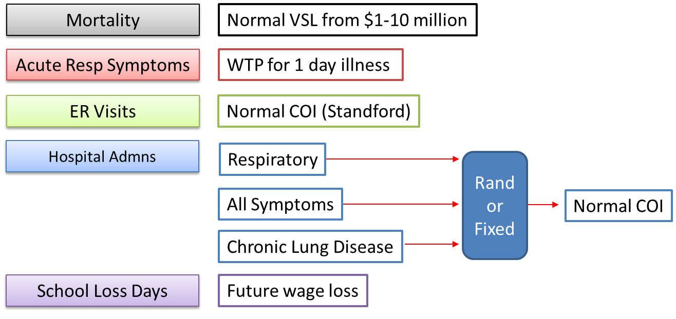

Figure 7: Change in avg. 8-hour max. ozone due to roll back to 70 ppb using data from 2013  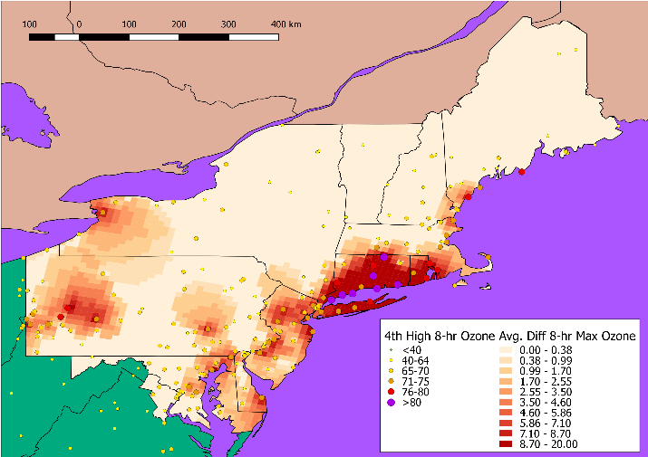 | Figure 8: Change in avg. 8-hour max. ozone due to roll back to 65 ppb using data from 2013  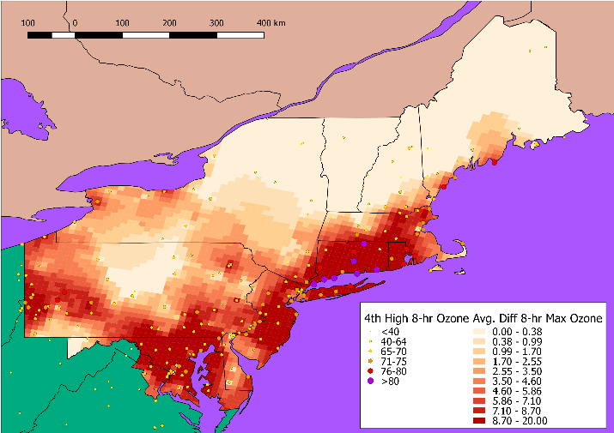 | Figure 9: Change in avg. 8-hour max. ozone due to roll back to 40 ppb using data from 2013  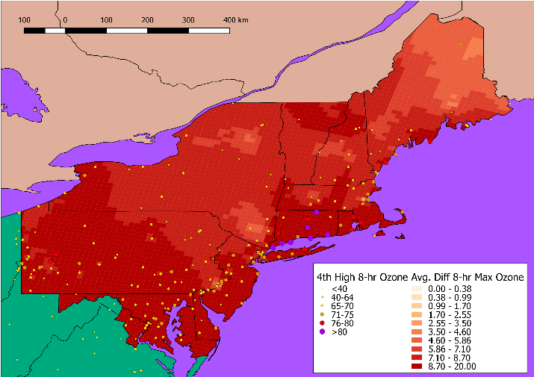
Figure 10: Change in avg. 8-hour max. ozone due to roll back to 70 ppb using data from 2014  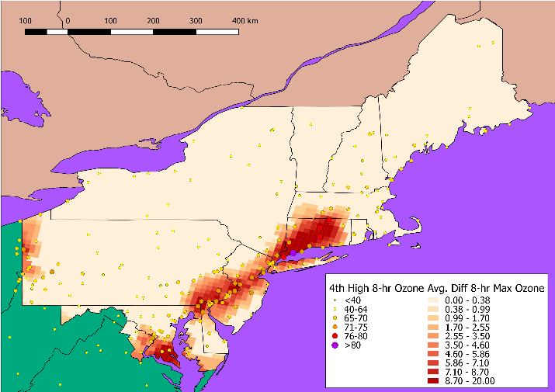 | Figure 11: Change in avg. 8-hour max. ozone due to roll back to 65 ppb using data from 2014  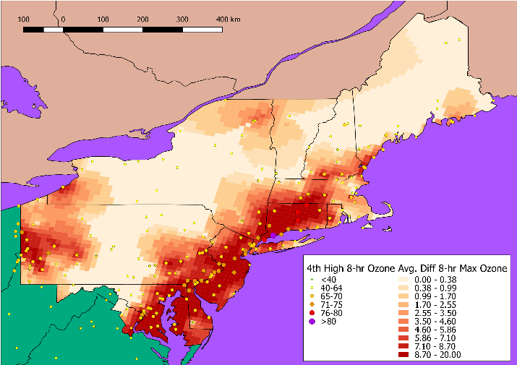 | Figure 12: Change in avg. 8-hour max. ozone due to roll back to 40 ppb using data from 2014  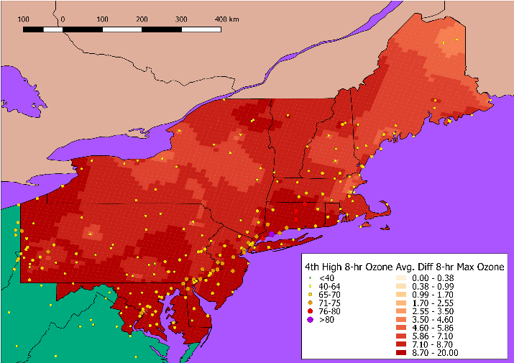
Figure 13: Change in avg. 8-hour max. ozone due to roll back to 70 ppb using data from 2015  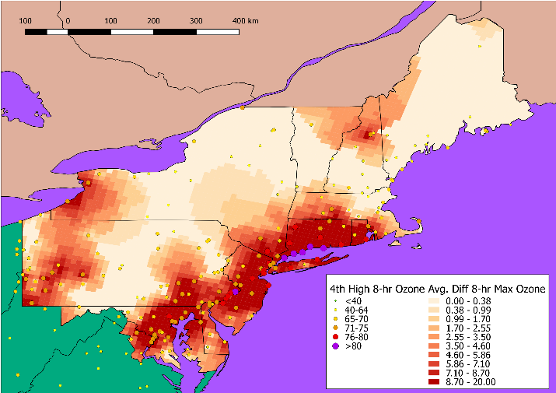 | Figure 14: Change in avg. 8-hour max. ozone due to roll back to 65 ppb using data from 2015  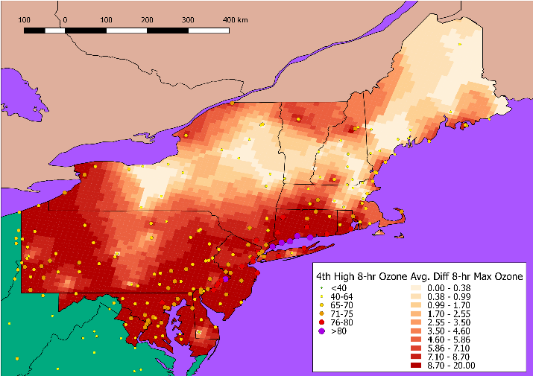 | Figure 15: Change in avg. 8-hour max. ozone due to roll back to 40 ppb using data from 2015
Figure 16: Change in avg. 8-hour max. ozone due to roll back to 70 ppb using data from 2016  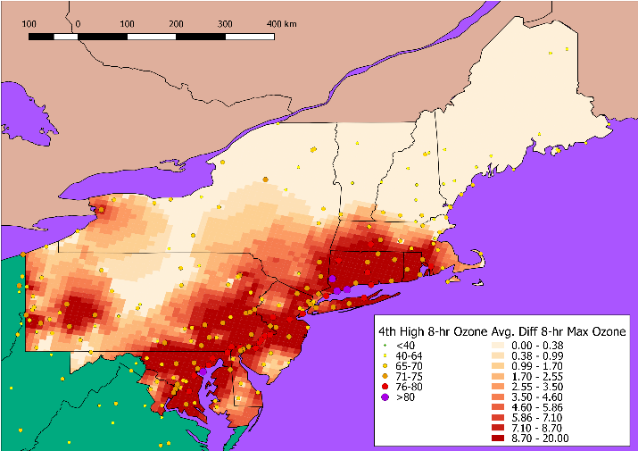 | Figure 17: Change in avg. 8-hour max. ozone due to roll back to 65 ppb using data from 2016  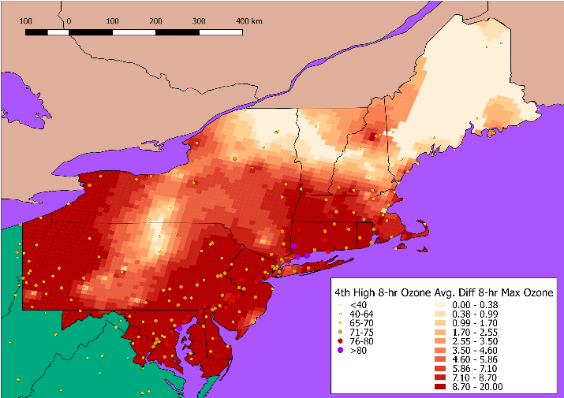 | Figure 18: Change in avg. 8-hour max. ozone due to roll back to 40 ppb using data from 2016  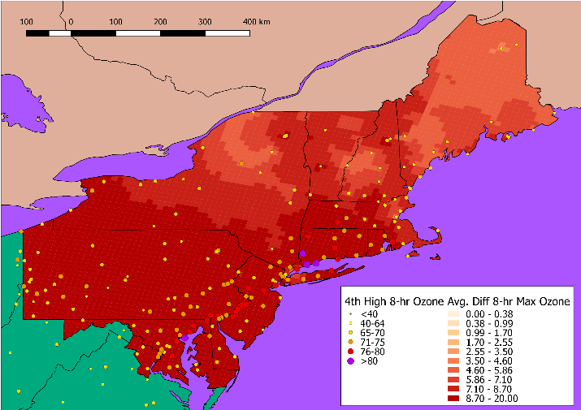

Results

Monitor Rollback
The majority of the reductions in ozone levels in 70 ppb rollbacks occurred in the I-95 corridor between Washington, DC and New York City, NY, with smaller reductions extending north to Boston, MA. Western Pennsylvania also saw reductions in the 70 ppb rollback scenarios except in 2014. Northern New Hampshire also saw reductions in the 70 ppb rollback scenario only in 2015 and Central Pennsylvania saw reductions in 2015 and 2016.
In the 65 ppb scenario the reductions were greater in the I-95 corridor and Western Pennsylvania, Eastern Pennsylvania, Central New York, and Northern New Hampshire saw reductions in all years. Several years also saw reductions in coastal Maine.
The entire region saw massive reductions in ozone levels in the 40 ppb rollback scenarios including many rural areas in the region.
Overview maps of the changes in average 8 hour maximum ozone concentrations in the OTR after being rolled back to 70 ppb in left most figures from Figure 3 through Figure 14 to 65 ppb in the center figures and to 40 ppb in the right most figures.

Health Impact
After processing the health impact functions, we found that had the entire OTR had 4th highest monitor results at or under 70 ppb it is expected that there would have been anywhere from 50 to 860 fewer short term mortalities due to ozone exposure. A similar pattern of results happened for 65 and 40 ppb rollbacks, but with higher levels of reduced mortality. Emergency room visit were not found to be significant different than 0. The same pattern of results occurred for the other health endpoints as mortality with the magnitude being of hospital admissions being about half of the mortality incidence, acute respiratory symptoms being roughly 2000 times, and school loss days being roughly 500 times. State level graphs showing the mean mortality for each year from 2013-2016 for having met 70 ppb, 65 ppb, and 40 ppb are in Figure 14, Figure 15, and Figure 16, respectively. A full listing of the reduced health incidence pooled for the OTR is in Table 3.
Figure 19: State mortalities reduced from meeting the 70 ppb NAAQS from 2013-2016

Figure 20: State mortalities reduced from meeting the 65 ppb NAAQS from 2013-2016

Figure 21: State mortalities reduced from meeting the 40 ppb NAAQS from 2013-2016

Economic Impact
Following analysis of the health impacts, economic impacts were estimated using the previously discussed techniques. The value of the mortalities outweigh the other economic impacts considerably, though one should consider that some economic benefits such as reduced personal suffering may not have been monetized for morbidity due to the data, such as cost of illness estimates, used in developing the cost estimates. Again emergency room visits were not found to be significantly different from zero, as were minor restricted activity days. Total economic benefits for the OTR, excluding emergency room visits and minor restricted activity days, are found for each year from 2013-2016 for having met 70 ppb, 65 ppb, and 40 ppb in Figure 22, Figure 23, and Figure 24, respectively. A full break down of the economic impacts is in Table 4.
Figure 22: State economic benefits from meeting the 70 ppb NAAQS from 2013-2016

Figure 23: State economic benefits from meeting the 65 ppb NAAQS from 2013-2016

Figure 24: State economic benefits from meeting the 40 ppb NAAQS from 2013-2016

Table 3: Estimated Ozone-Related Health Impacts Following Monitor Rollback to 70, 65, and 40 ppb for 2013-2016 in the OTR
 | Mortality, All Causes |  |  | Emergency Room Visits Respiratory |  |  | Hospital Admissions Respiratory |  |  | Acute Respiratory Symptoms |  |  | School Loss Days
 | Mean | -2σ | 2σ | Mean | -2σ | 2σ | Mean | -2σ | 2σ | Mean | -2σ | 2σ | Mean | -2σ | 2σ
2013
40 | 2,280 | 1,146 | 3,415 | 2,247 | -449 | 4,944 | 1,284 | 377 | 2,191 | 4,197,816 | 1,892,705 | 6,502,927 | 1,202,964 | 486,281 | 1,919,647
65 | 1,620 | 813 | 2,427 | 1,689 | -339 | 3,717 | 927 | 274 | 1,581 | 3,075,827 | 1,381,628 | 4,770,027 | 890,618 | 360,100 | 1,421,135
70 | 817 | 410 | 1,224 | 911 | -184 | 2,006 | 466 | 142 | 789 | 1,610,165 | 721,417 | 2,498,912 | 456,384 | 184,554 | 728,213
2014
40 | 2,193 | 1,101 | 3,284 | 2,175 | -435 | 4,786 | 1,246 | 365 | 2,127 | 4,045,310 | 1,822,237 | 6,268,383 | 1,152,382 | 465,887 | 1,838,876
65 | 1,378 | 692 | 2,065 | 1,535 | -308 | 3,378 | 788 | 237 | 1,339 | 2,648,090 | 1,188,791 | 4,107,388 | 752,984 | 304,483 | 1,201,484
70 | 97 | 48 | 145 | 111 | -16 | 237 | 57 | 16 | 98 | 194,477 | 85,659 | 303,295 | 54,890 | 22,216 | 87,563
2015
40 | 2,642 | 1,331 | 3,953 | 2,601 | -511 | 5,713 | 1,489 | 449 | 2,530 | 4,747,440 | 2,164,519 | 7,330,360 | 1,374,614 | 485,734 | 2,263,494
65 | 2,142 | 1,076 | 3,207 | 2,164 | -432 | 4,760 | 1,205 | 367 | 2,043 | 3,877,164 | 1,748,947 | 6,005,381 | 1,098,322 | 444,039 | 1,752,605
70 | 1,716 | 862 | 2,570 | 1,928 | -384 | 4,240 | 978 | 299 | 1,657 | 3,299,106 | 1,489,185 | 5,109,027 | 928,840 | 375,517 | 1,482,164
2016
40 | 2,620 | 1,317 | 3,923 | 2,545 | -506 | 5,595 | 1,501 | 446 | 2,557 | 4,677,157 | 2,115,095 | 7,239,219 | 1,311,394 | 530,069 | 2,092,719
65 | 2,266 | 1,139 | 3,394 | 2,276 | -454 | 5,006 | 1,294 | 384 | 2,204 | 4,099,376 | 1,849,093 | 6,349,658 | 1,147,950 | 464,077 | 1,831,822
70 | 1,698 | 853 | 2,543 | 1,736 | -347 | 3,819 | 983 | 301 | 1,665 | 3,132,862 | 1,410,641 | 4,855,084 | 880,268 | 355,906 | 1,404,630
Table 4: Estimated Ozone-Related Economic Impacts (2010$) Following Monitor Rollback to 70, 65, and 40 ppb for 2013-2016 in the OTR
 | Mortality, All Causes |  |  | Emergency Room Visits, Asthma |  |  | Hospital Admissions Respiratory
 | Mean | -2σ | 2σ | Mean | -2σ | 2σ | Mean | -2σ | 2σ
2013
40 | $11,519,485,792 | $170,072,048 | $22,868,899,536 | $509,316 | -$101,640 | $1,120,272 | $21,681,375 | $5,500,972 | $37,861,779
65 | $9,384,812,704 | $136,750,106 | $18,632,875,302 | $427,626 | -$85,729 | $940,981 | $17,854,061 | $4,591,009 | $31,117,112
70 | $5,113,000,701 | $73,367,741 | $10,152,633,661 | $238,148 | -$48,003 | $524,299 | $9,966,407 | $2,500,940 | $17,431,873
2014
40 | $12,471,234,255 | $163,240,374 | $24,779,228,136 | $495,992 | -$99,509 | $1,091,493 | $20,674,349 | $5,382,028 | $35,966,671
65 | $7,950,936,124 | $114,978,588 | $15,786,893,660 | $347,812 | -$69,830 | $765,455 | $13,264,398 | $3,388,041 | $23,140,755
70 | $3,676,306,592 | $52,454,418 | $7,300,158,766 | $189,667 | -$38,234 | $417,568 | $6,147,040 | $1,604,490 | $10,689,590
2015
40 | $13,526,233,880 | $202,842,248 | $26,849,625,512 | $600,523 | -$119,090 | $1,320,137 | $25,622,879 | $6,657,492 | $44,588,266
65 | $10,819,146,524 | $160,019,168 | $21,478,273,880 | $490,483 | -$97,806 | $1,078,773 | $20,357,843 | $5,265,817 | $35,449,868
70 | $8,669,561,586 | $128,426,438 | $17,210,696,734 | $436,934 | -$86,989 | $960,857 | $16,439,036 | $4,315,551 | $28,562,521
2016
40 | $15,255,727,776 | $228,054,912 | $30,283,400,640 | $576,679 | -$114,542 | $1,267,901 | $25,314,355 | $6,567,577 | $44,061,133
65 | $13,196,190,772 | $194,904,888 | $26,197,476,656 | $515,766 | -$102,811 | $1,134,343 | $21,806,648 | $5,638,167 | $37,975,128
70 | $9,887,347,069 | $145,099,195 | $19,629,594,943 | $393,345 | -$78,685 | $865,375 | $16,638,993 | $4,292,512 | $28,985,474
 | Minor Restricted Activity Days |  |  | School Loss Days
2013
40 | $93,033,327 | -$29,589,066 | $215,655,720 | $81,691,996 | $33,186,346 | $130,197,645
65 | $77,393,080 | -$24,668,140 | $179,454,300 | $68,301,008 | $27,746,898 | $108,855,117
70 | $42,458,928 | -$13,567,426 | $98,485,281 | $36,864,577 | $14,976,270 | $58,752,884
2014
40 | $92,449,008 | -$29,624,650 | $214,522,666 | $79,107,465 | $27,295,867 | $130,919,064
65 | $61,688,814 | -$19,686,569 | $143,064,197 | $51,134,326 | $20,773,428 | $81,495,224
70 | $30,452,374 | -$9,742,403 | $70,647,150 | $24,993,965 | $10,154,098 | $39,833,831
2015
40 | $107,488,235 | -$34,076,689 | $249,053,160 | $92,946,422 | $37,758,059 | $148,134,785
65 | $85,925,006 | -$27,316,821 | $199,166,833 | $74,585,860 | $30,300,006 | $118,871,715
70 | $73,112,556 | -$23,230,578 | $169,455,690 | $63,076,564 | $25,624,412 | $100,528,715
2016
40 | $109,304,954 | -$34,676,755 | $253,286,663 | $89,055,374 | $36,177,323 | $141,933,425
65 | $95,810,665 | -$30,462,266 | $222,083,595 | $77,956,033 | $31,668,925 | $124,243,140
70 | $73,226,288 | -$23,313,403 | $169,765,979 | $59,778,074 | $24,284,628 | $95,271,519

US EPA, “2015 National Ambient Air Quality Standards for Ozone.”
Di et al., “Air Pollution and Mortality in the Medicare Population.”
US EPA, “Environmental Benefits Mapping and Analysis Program – Community Edition: User’s Manual.”
Lin Zhang et al., “Improved Estimate of the Policy-Relevant Background Ozone in the United States Using the GEOS-Chem Global Model with 1/2° × 2/3°Horizontal Resolution over North America”; US EPA, Integrated Science Assessment for Ozone and Related Photochemical Oxidants.
Jerrett et al., “Long-Term Ozone Exposure and Mortality.”
Bell, Dominici, and Samet, “A Meta-Analysis of Time-Series Studies of Ozone and Mortality with Comparison to the National Morbidity, Mortality, and Air Pollution Study.”
Peel et al., “Ambient Air Pollution and Respiratory Emergency Department Visits.”
Wilson et al., “Air Pollution, Weather, and Respiratory Emergency Room Visits in Two Northern New England Cities: An Ecological Time-Series Study”; Peel et al., “Ambient Air Pollution and Respiratory Emergency Department Visits.”
Moolgavkar, Luebeck, and Anderson, “Air Pollution and Hospital Admissions for Respiratory Causes in Minneapolis-St. Paul and Birmingham”; Schwartz, “PM10 Ozone, and Hospital Admissions for the Elderly in Minneapolis-St. Paul, Minnesota”; Schwartz, “Air Pollution and Hospital Admissions for the Elderly in Detroit, Michigan.”
Schwartz, “PM10 Ozone, and Hospital Admissions for the Elderly in Minneapolis-St. Paul, Minnesota.”
Schwartz, “Air Pollution and Hospital Admissions for the Elderly in Detroit, Michigan.”
Schwartz, “Short Term Fluctuations in Air Pollution and Hospital Admissions of the Elderly for Respiratory Disease.”
Burnett et al., “Association between Ozone and Hospitalization for Acute Respiratory Diseases in Children Less than 2 Years of Age.”
Ostro and Rothschild, “Air Pollution and Acute Respiratory Morbidity: An Observational Study of Multiple Pollutants.”
Chen et al., “Elementary School Absenteeism and Air Pollution.”
Gilliland et al., “The Effects of Ambient Air Pollution on School Absenteeism due to Respiratory Illnesses.”

